# Clonezilla

## **Backup/clone an OS or HDD as image**

1. Enter bios by pressing DEL (may differ) as the computer boots up.
2. Navigate towards Boot and ensure Boot option # 1 is the flash drive in which Clonezilla’s image is installed (use Etcher or similar to install Clonezilla).
3. Save and exit
4. The Clonezilla home screen will be presented once the computer is rebooted, press enter or wait 30 seconds
5. Select the language
6. Select Keyboard Configuration
7. Start Clonezilla or Login Shell, Select “Start_Clonezilla”
8. Clonezilla – Open Source Clone System (OCS) , Select “device – image”
9. Mount Clonezilla image directory, Select “local_dev”

Searches for the drive – where the backup image will be saved. Press Ctrl-C to exit

1. OCS – Mount a device, i.e. select the drive where the image will be saved. Do not select the hard disk or the drive to be cloned.
2. Directory Browser for Clonezilla image repository – Select folder where image has to be saved.
3. OCS – Select Beginner Mode
4. OCS (Select Mode) – Select “savedisk Save_local_disk_as_an_image”
5. OCS | Mode: savedisk – Choose a name for the image
6. OCS | Mode: savedisk – Choose the source of which the image is to be cloned (usually HDD)
7. (Optional) Clonezilla advanced extra parameters | Mode: restoredisk – Choose whether to check the image or not
8. (Optional) Mode: restoredisk - Choose action when everything is finished

## **Restoring a saved image**

1. Enter bios by pressing DEL (may differ) as the computer boots up.
2. Navigate towards Boot and ensure Boot option # 1 is the flash drive in which Clonezilla’s image is installed (use Etcher or similar to install Clonezilla).
3. Save and exit
4. The Clonezilla home screen will be presented once the computer is rebooted, press enter or wait 30 seconds
5. Select the language
6. Select Keyboard Configuration
7. Start Clonezilla or Login Shell, Select “Start_Clonezilla”
8. Clonezilla – Open Source Clone System (OCS) , Select “device – image”
9. Mount Clonezilla image directory, Select “local_dev”

Searches for flash drive – with the image to be restored. Press Ctrl-C to exit

1. OCS – Mount a device, i.e. select the flash drive where the image to be restored is available. Do not select the empty hard disk.
2. Directory Browser for Clonezilla image repository – The folder with the image should be selected. It should have “CZ_IMG” at the end of the folder. Else browse and find the appropriate folder.
3. OCS – Select Beginner Mode
4. OCS (Select Mode) – Select “restoredisk Restore_an_image_to_local_disk”
5. OCS | Mode: restoredisk – Ensure correct image is selected
6. OCS | Mode: restoredisk – Choose the target disk
7. (Optional) Clonezilla advanced extra parameters | Mode: restoredisk – Choose whether to check the image or not
8. (Optional) Mode: restoredisk - Choose action when everything is finished

### **Destination disk is too small**

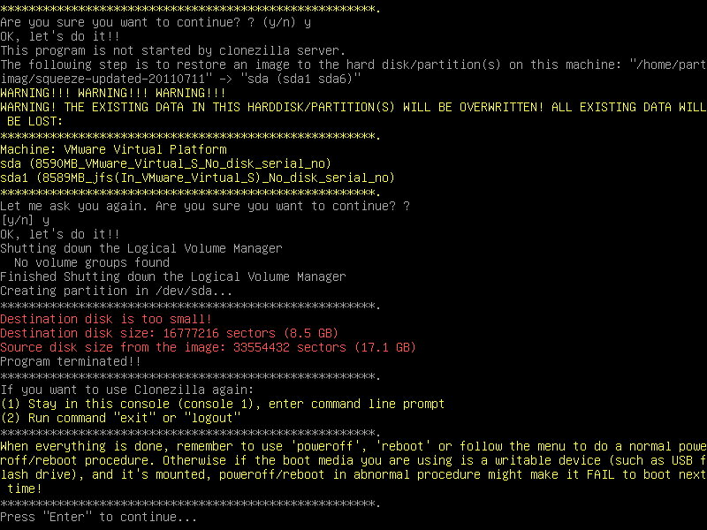

Follow the above instructions up to step 10

1. In Step 11 – Choose expert mode
2. OCS (Select Mode) – Select “restoredisk Restore_an_image_to_local_disk”
3. OCS | Mode: restoredisk – Ensure correct image is selected
4. OCS | Mode: restoredisk – Choose the target disk
5. NCHC Free Software… advanced parameter – Navigate towards “icds” using down arrow. Select “icds” using spacebar. An asterisks will be visible to confirm selection.
6. OCS | Mode: restoredisk – It is safe to select “k1” or “Create partition table proportionally” 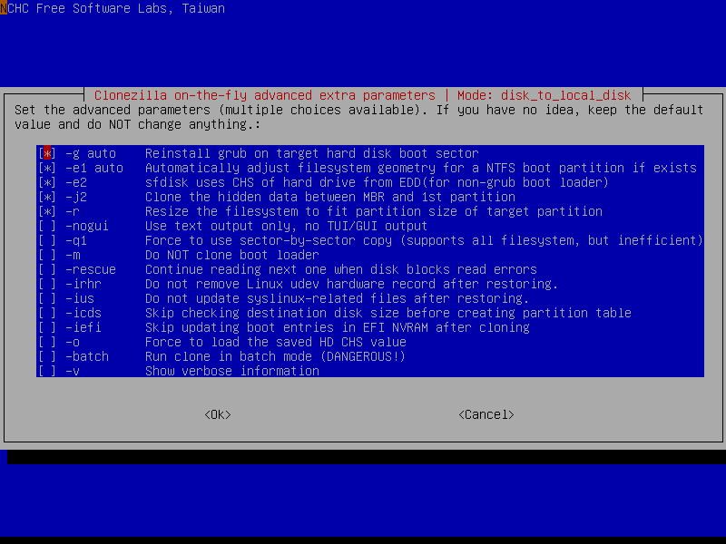
7. (Optional) Clonezilla advanced extra parameters | Mode: restoredisk – Choose whether to check the image or not
8. (Optional) Mode: restoredisk - Choose action when everything is finished